FACULTY OF COMPUTER ENGINEERING INFORMATICS AND COMMUNICATIONS
DEPARTMENT OF ANALYTICS AND INFORMATICS

LEVERAGING MACHINE LEARNING FOR PREDICTING HOSPITAL READMISSIONS IN ACUTE DECOMPENSATED HEART FAILURE (ADHF)

BY

SHANIA K T RUWENDE

SUPERVISED BY:

DR KWANGWA

THIS CAPSTONE RESEARCH PROJECT WAS SUBMITTED TO THE UNIVERSITY OF ZIMBABWE IN PARTIAL FULFILMENT OF THE BACHELOR OF SCIENCE (HONOURS) DEGREE IN DATA SCIENCE AND INFORMATICS

2026

DECLARATION
I, Shania K T Ruwende, declare that this dissertation titled “Leveraging Machine Learning for Predicting Hospital Readmissions in Acute Decompensated Heart Failure (ADHF)” is my own work. It has been carried out under the supervision of Dr. Kwangwa. It has not been submitted in any form for any other degree or diploma at this or any other university.
Where other sources of information have been used, they have been duly acknowledged through proper referencing. I further declare that I have completed this research project sincerely and to the best of my knowledge and ability.
Shania K T Ruwende
Date: ________________

COPYRIGHT
I, Shania K T Ruwende, the author of this dissertation entitled “Leveraging Machine Learning for Predicting Hospital Readmissions in Acute Decompensated Heart Failure (ADHF)”,
Hereby grant the University of Zimbabwe the non-exclusive right to reproduce this dissertation in whole or in part, in any format, for research, teaching, and academic archiving.
I understand that the University of Zimbabwe may make and distribute copies of this work for academic purposes only.
However, I reserve all other rights, including the right to publish this work in journals, books, or any other medium, in whole or in part. No part of this dissertation may be reproduced for commercial purposes without my prior written consent.
Signed: ___________________________ Shania K T Ruwende
Date: ________________

DEDICATION
I dedicate this dissertation firstly to God, who has protected me through and through, to my loving family, especially my Guardians, for their unwavering support, sacrifices, and encouragement throughout my academic journey.
To my supervisors, lecturers, and friends who believed in me and walked this path with me, thank you.
This work is also dedicated to all healthcare workers in Zimbabwe and across sub-Saharan Africa who continue to serve with dedication despite limited resources. May this research contribute, in some small way, toward better patient care and improved health outcomes.

ABSTRACT

ACKNOWLEDGEMENTS
I wish to express my heartfelt appreciation to my supervisor, Dr. Nancy Kwangwa, for her expert guidance, insightful comments, and continuous support throughout this research.
My sincere thanks also go to the academic staff of the Department of Analytics and Informatics for their valuable contributions to my learning.
I am profoundly grateful to my family for their unconditional love, patience, and encouragement. To my friends and colleagues, thank you for your moral support.
I acknowledge the MIMIC dataset providers for making critical care data openly accessible, which enabled this study.
Above all, I thank God for the strength and opportunity to complete this dissertation.
Shania K T Ruwende

TABLE OF CONTENTS

Table of Contents
DECLARATION i
COPYRIGHT ii
DEDICATION i
ABSTRACT ii
ACKNOWLEDGEMENTS iii
TABLE OF CONTENTS iv
CHAPTER 1. INTRODUCTION 1
1.1 Introduction 1
1.2 Background 1
1.3 Problem statement 2
1.4 Aim 2
1.5 Research objectives 3
1.6 Research Questions 3
1.7 Scope and limitations of the project: 3
1.8 Significance and motivation for the project: 4
1.9 Work plan: 5
1.10 Conclusion: 6
CHAPTER 2 LITERATURE REVIEW 7
2.1 Introduction: 7
2.2 Review of relevant literature: 7
2.3 Discussion of similar projects or systems: 9
2.3 Identification of gaps or areas for improvement: 10
2.4 Conclusion: 11
CHAPTER 3. RESEARCH METHODOLOGY 12
3.1 Introduction 12
3.2 Research Design and Experimental Plan 12
3.2.1 Data Acquisition and Variable Definition 13
3.2.2 Model Selection Strategy and Explainability Perspective 14
3.2.3 Evaluation Framework 14
3.3.1 Data Preprocessing 15
3.3.2 Data Partitioning and Validation Protocol 15
3.3.3 Model Training and Assessment Procedure 16
3.3.4 Interpretability Analysis Procedure 16
3.4 Reproducibility and Validity Considerations 16
3.5 Ethical Considerations 16
3.6 Chapter Summary 17
CHAPTER 4. PROCESS AND MODEL DESIGN 18
4.1 Introduction 18
4.2 Overall System Architecture 18
4.3 Design of the ADHF Readmission Prediction Model 19
4.3.1 Model Architecture and Design Rationale 19
4.3.2 Mathematical Formulation 20
4.3.3 Design-Level Code Realization 21
4.4 Explainable AI (XAI) Integration Design 22
4.4.1 Explanation Generation Mechanism 22
4.4.2 Explanation Output Design 22
4.4.3 Clinical Interpretation Layer 23
4.5 Chapter Summary 23

CHAPTER 1. INTRODUCTION

1.1 Introduction
This chapter introduces the project, establishes its background and context, clearly defines the problem under investigation, and outlines the study's objectives, scope, feasibility, and significance. It lays the foundation for understanding why an explainable, systems-based machine learning approach is necessary to predict hospital readmission among ADHF patients.

1.2 Background
Hospital readmissions are still one of the biggest headaches in healthcare, especially for people living with heart failure (HF). A major international study that pooled data from more than 1.4 million HF patients across 18 countries found that, on average, about 13.2% of them end up back in the hospital within 30 days of being discharged [1]. These repeat visits don’t just hurt patients; they increase the risk of dying, lower quality of life, and put huge pressure on already stretched health systems.
In sub-Saharan Africa, including right here in Zimbabwe, things are even tougher. With far fewer heart specialists, limited diagnostic equipment, and patchy follow-up care, readmission rates climb much higher, sometimes as high as 26% within 30 days, compared to the global average of 13.2%. One-year mortality can reach 33.6% here, more than double what’s seen in many wealthier countries [2]. A lot of this comes down to hypertension being the main driver of heart failure in our region, combined with everyday barriers like low insurance coverage and overcrowded public hospitals. That’s why tools that can predict who’s most at risk before they leave the hospital feel especially urgent in places like ours.
Machine learning has started to change the game in better-resourced settings. Recent reviews show that these models, especially ensemble methods and deep learning, can spot complicated patterns in patient records, lab results, and vital signs that traditional scoring systems often miss. On average, they reach AUC scores between 0.72 and 0.80 for predicting 30-day readmissions, usually doing better than older tools [3], [4] Some newer studies are even using explainable techniques like SHAP to make the predictions easier for doctors to understand and trust, particularly in acute heart failure cases [5], [6]
But here’s the catch: almost all of these models were built using data from Western countries or very general heart failure populations. They don’t always translate well to Acute Decompensated Heart Failure (ADHF) in African settings, where patients can become unstable very quickly and face very different health challenges. Very few studies focus specifically on ADHF, properly handle the fact that readmissions are rare events (class imbalance), or build full, practical systems that doctors in under-resourced hospitals can actually use day-to-day.
That leaves a real gap in this research that is trying to help fill: we need prediction tools that are accurate, transparent, and actually built with African patients and hospitals in mind.

1.3 Problem statement
Even though machine learning has made real progress in predicting readmissions for heart failure patients, there’s still a serious data science and informatics challenge when it comes to Acute Decompensated Heart Failure (ADHF) in places like sub-Saharan Africa. Most existing models were trained on data from high-income countries and only manage moderate performance when applied elsewhere, typically with AUC scores of 0.72 – 0.80 [3], [4] They often struggle to pick up on the sudden instability that defines ADHF, the unique mix of conditions our patients have, and the everyday realities of limited access to healthcare.
The biggest issue is that we don’t yet have many disease-specific, easy-to-understand models designed for ADHF. Most stay “black-box,” which makes doctors hesitant to rely on them. They don’t always handle the fact that readmissions are uncommon (so the data is imbalanced), and very few combine structured information (labs, vitals, medications) with unstructured notes into a single, clear system. Even fewer wrap explainable AI like SHAP into a practical decision-support tool that actually fits into busy, low-resource hospital workflows.
This project tackles exactly that problem. It aims to build an explainable machine learning framework specifically for predicting 30-day readmissions in ADHF patients, models that are strong technically but also transparent enough for clinicians to trust, so they can spot high-risk patients early, personalise care, and help cut down on preventable returns to hospital in settings like Zimbabwe.

1.4 Aim
This research aims to develop and evaluate an explainable machine learning framework for predicting 30-day hospital readmissions among patients with Acute Decompensated Heart Failure (ADHF).

1.5 Research objectives
- To collect and preprocess clinical data related to ADHF patients, including structured variables (e.g., laboratory results, vital signs, and medication records), and prepare a clean dataset suitable for machine learning analysis within the initial phase of the study.
- To perform exploratory data analysis (EDA) to identify key patterns, correlations, and risk factors associated with 30-day hospital readmissions among ADHF patients before model development.
- To develop and train multiple machine learning models (e.g., Logistic Regression, Random Forest, and Gradient Boosting) for predicting 30-day readmissions, and compare their performance using evaluation metrics such as Accuracy, Precision, Recall, F1-score, and AUC.
- To address class imbalance in the dataset by applying appropriate techniques (e.g., SMOTE, undersampling, or class weighting) and evaluate their impact on model performance.
- To implement explainable artificial intelligence techniques, specifically SHAP (Shapley Additive exPlanations), to interpret model predictions and identify the most influential features contributing to readmission risk.

Research Questions
- What are the key clinical, demographic, and laboratory factors associated with 30-day hospital readmissions among ADHF patients?
- Which machine learning models can most accurately predict 30-day readmissions in ADHF patients?
- How does addressing class imbalance in the dataset affect the predictive performance of machine learning models for 30-day readmission?
- How can explainable AI techniques, such as SHAP, help identify the most influential factors contributing to readmission risk and improve clinical interpretability?
- How can the best-performing predictive model be integrated into a prototype decision-support system suitable for clinical use in low-resource hospital settings?

Scope and limitations of the project:
Scope
This project focuses on predicting 30-day hospital readmissions among patients with Acute Decompensated Heart Failure (ADHF). It utilizes both structured data, including laboratory results, vital signs, and medication records, and unstructured data such as discharge summaries to provide a comprehensive view of patient health. Machine learning techniques are applied to develop predictive models, while interpretability tools are incorporated to ensure that model outputs are understandable and actionable for clinicians.
In addition to model development and evaluation, the project includes data preprocessing, feature selection, class imbalance handling, and the application of explainable AI methods. A high-level system design is also proposed as a dashboard prototype to support clinical decision-making. Overall, the project encompasses the full pipeline from data preparation to model deployment considerations, emphasizing the creation of an explainable, practical decision-support tool for use in healthcare settings.
Limitations
Despite its comprehensive approach, the project has several limitations. First, it does not involve live deployment within hospitals or integration with real-time patient data, which limits the assessment of system performance under actual clinical conditions. Second, the datasets used for model development may not fully represent the diversity of patient populations in Zimbabwe, potentially affecting the generalizability of the findings. Third, due to time and resource constraints, certain unstructured data types, such as detailed clinical notes and physician narratives, are not included in the analysis. Finally, the study focuses on model development and interpretability rather than evaluating long-term clinical outcomes resulting from system use.

Significance and motivation for the project:
Hospital readmissions, particularly for Acute Decompensated Heart Failure (ADHF), remain a critical issue in healthcare, contributing to increased mortality, reduced patient quality of life, and significant financial strain on health systems. [7], [8], [9]]. By applying machine learning techniques, this project aims to provide more accurate and timely readmission risk predictions, enabling clinicians to intervene earlier and personalize patient care. [10], [11]
The integration of explainable AI methods ensures that the models developed are not only accurate but also transparent, fostering trust among healthcare professionals [12]. This balance between performance and interpretability enhances the likelihood of clinical adoption, making the research practically relevant. Furthermore, the project contributes to ongoing efforts to reduce healthcare costs and improve patient outcomes, aligning with global priorities in sustainable healthcare delivery [13].

1.9 Work plan:
The project is structured into phases, including data integration,Machine learning model development, system design, validation, and documentation. A detailed Gantt chart outlines these activities across the project timeline.
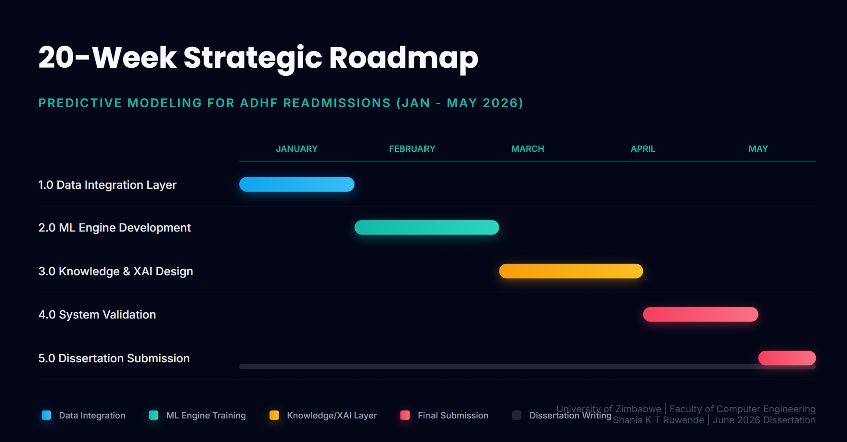

The 20-week strategic roadmap for this system is designed to balance technical complexity with the formal requirements of this capstone project. The timeline is structured as follows:
- Foundation (Weeks 1–4): The project begins with Data Integration, focusing on cleaning and profiling the clinical datasets to ensure a high-quality "feature space" for the models.
- Technical Core (Weeks 5–14): Development is split into two heavy-duty phases. First, the Machine Learning Engine is trained and optimized (Weeks 5–9). Once the model is stable, the project transitions to the Knowledge and XAI Design (Weeks 10–14), where explainability layers such as SHAP or LIME are integrated to ensure clinicians can understand the risk predictions.
- Validation and Delivery (Weeks 15–20): The final stage involves rigorous System Validation and User Acceptance Testing (UAT). The roadmap concludes with a two-week final push for Dissertation Submission. However, the chart emphasizes that documentation is written in parallel throughout the 5 months to ensure high-quality academic output.

1.10 Conclusion:
This chapter introduced the motivation, objectives, and scope of the project. It established the need for an explainable, ADHF-specific machine learning system and laid the groundwork for the detailed literature review presented in the next chapter.

CHAPTER 2 LITERATURE REVIEW

2.1 Introduction:
This chapter presents a comprehensive and critical examination of recent literature on the application of machine learning to predict hospital readmissions, with particular attention to patients with heart failure (HF), and, more specifically, to acute decompensated heart failure (ADHF). Drawing on peer-reviewed studies published between 2021 and early 2026, the review explores the evolution of predictive modelling techniques, the growing emphasis on explainable AI (XAI), strategies for addressing class imbalance, and the challenges of translating models into clinical practice.
The discussion is organised thematically to highlight major trends, evaluate strengths and limitations of existing approaches, and identify persistent gaps in the literature. In doing so, this chapter establishes the foundation for the present research, which seeks to develop an ADHF-specific, interpretable machine learning framework that integrates structured clinical data, effectively manages class imbalance, delivers clinician-friendly explanations, and conceptualises a practical decision-support system tailored to resource-constrained healthcare environments such as those in Zimbabwe.

2.2 Review of relevant literature:
Recent meta-analyses provide a balanced assessment of machine learning performance in predicting 30-day readmissions among patients with heart failure. A 2025 meta-analysis encompassing 346 models reported pooled AUC values for readmission generally ranging from 0.70 to 0.73, with support vector machines reaching 0.726. Mortality prediction performed somewhat better, with AUCs between 0.79 and 0.81, commonly achieved using random forest, gradient boosting, and neural networks [3]. A separate 2025 systematic review of larger cohorts (over 1,000 patients) indicated a median AUC of approximately 0.82 for 30-day readmissions, once again emphasising the superiority of ensemble methods such as random forest, gradient boosting, and XGBoost in capturing complex, non-linear relationships within electronic health record data. [4].
Research focusing specifically on acute decompensated heart failure has yielded particularly relevant insights. Zhang et al. (2024) developed an XGBoost model for acute HF patients that attained an AUC of 0.763 (95% CI: 0.703–0.824), outperforming traditional logistic regression. SHAP analysis identified key contributing factors, including interventricular septal thickness, age, length of hospital stay, calcium, albumin, systolic blood pressure, left atrial diameter, creatinine, and cholinesterase, with inflammation and metabolic disturbances playing prominent roles [5]. Similarly, Zang et al. (2026) constructed an interpretable model using random forests and XGBoost for advanced heart failure, in which SHAP revealed significant synergistic interactions between inflammatory and metabolic biomarkers in 30-day readmission risk [14].
These findings hold special relevance for sub-Saharan Africa, where heart failure frequently manifests with more acute decompensation linked to hypertension and limited continuity of care. A 2025 study on heart failure with preserved ejection fraction (HFpEF) employing LightGBM achieved an AUC of 0.88 (0.87 on external validation), with SHAP analysis highlighting the E/e’ ratio, NYHA class, LVEF, age, BNP, and comorbidities as critical drivers, thereby reinforcing the importance of inflammation and cardiac mechanics in acute episodes. [15].
Explainable AI techniques, particularly SHAP and LIME, have gained prominence as essential tools for fostering clinical trust. Salih et al. (2025) provide a clear overview of how these methods generate both global feature importance rankings and patient-specific explanations [[16]. Nevertheless, Allgaier et al. (2023), after systematically reviewing numerous healthcare ML studies, observed that although SHAP and LIME enhance transparency, many implementations remain too technical for routine clinical decision-making. [17]. Wang et al. (2026) applied SHAP in a stacking ensemble for elderly patients with concurrent type 2 diabetes and heart failure, achieving an AUC of 0.867, with CRP, eGFR, and BNP emerging as the most influential variables. [6]. Luo et al. (2024) utilised a CatBoost model with SHAP interpretation for 1-year readmission risk (AUC 0.836), effectively visualising interactions among NT-proBNP, NYHA class, LVEF, and smoking history. [18].
Class imbalance remains a significant challenge, as readmission events typically constitute only 15–25% of datasets. Techniques such as SMOTE, mixed sampling, and cost-sensitive learning are frequently employed to mitigate this issue. [19], [20]. Rahman et al. (2023) demonstrated the effectiveness of stacking ensembles combined with SMOTE, attaining an AUC of 0.881 for emergency heart failure readmission prediction. [20].
Deep learning approaches have shown value when modelling time-series vital signs or unstructured clinical notes, although they often compromise interpretability [21]. On the topic of feature representation, Shakya et al. (2025) found that word2vec embeddings derived from electronic health records, when combined with XGBoost, improved AUROC by 0.11 compared with traditional one-hot encoding for 30-day heart failure readmission prediction [22].
Collectively, these studies indicate meaningful advancement, with optimised models achieving AUCs between 0.75 and 0.88 in controlled settings. However, performance frequently declines in real-world applications due to population heterogeneity, data quality variations, and the distinct acute characteristics of ADHF, particularly within resource-limited healthcare systems [3], [4].

2.3 Discussion of similar projects or systems:
A number of studies have addressed aspects of readmission prediction that align closely with the objectives of this research, yet important differences remain evident.
Sabouri et al. (2023) employed feature selection techniques (Boruta and MRMR) with support vector machines and logistic regression to predict 30-day HF readmissions and mortality, reporting AUCs around 0.73. While the feature engineering was effective, the study lacked explainability components and demonstrated only moderate performance on extended time horizons [11].
Ru et al. (2023) compared several algorithms for predicting readmissions and worsening events in heart failure with reduced ejection fraction, confirming the superiority of ensemble methods, although interpretability was not a primary consideration [10].
Mohanty et al. (2022) developed explainable deep learning models for frailty-associated readmission risk and incorporated SHAP for interpretation. This work shares conceptual similarities with the present research, particularly in its emphasis on explainability, yet it did not focus specifically on ADHF [23].
Okoye et al. (2023) integrated frailty and comorbidity measures into machine learning models for HF mortality and re-hospitalisation, achieving improved risk stratification. However, the study stopped short of designing a complete decision-support system [24].
In a context more relevant to Zimbabwe, Mpofu et al. (2024) constructed a Random Forest model for diabetic patient readmissions (accuracy ≈ 0.89) using the CRISP-DM methodology and highlighted its potential applicability in high-prevalence African settings. Nevertheless, the model omitted explainable AI techniques, relied on basic preprocessing, and targeted diabetes rather than ADHF [25].
Additional regionally pertinent work includes Rizinde et al. (2023), who evaluated multiple classifiers for heart failure readmission prediction using data from Rwanda and similarly identified challenges related to generalisability and class imbalance [26].
The most technically aligned studies are those by Zhang et al. (2024) and Zang et al. (2026), both of which applied XGBoost and random forest with SHAP to acute and advanced HF readmission prediction, emphasising the role of inflammation [5], [14]. Hu et al. (2025) achieved strong results with LightGBM for HFpEF readmission (AUC 0.88) and provided detailed SHAP insights [15], while Zeng et al. (2024) developed an XGBoost model for the vulnerable phase of acute HF, identifying uric acid, D-dimer, and NYHA class as key predictors [27]. Pikatza-Huerga et al. (2025) further advanced practical modelling by addressing class imbalance and missing data across multiple hospitals, although their work did not extend to a full informatics system [28].
This research differentiates itself by concentrating exclusively on ADHF, incorporating robust imbalance mitigation strategies, delivering clinician-oriented SHAP explanations, unifying structured clinical features (with scope for limited unstructured data), and conceptualising an end-to-end decision-support framework suited to the operational constraints of public hospitals.

2.3 Identification of gaps or areas for improvement:
Despite notable progress, several important gaps persist in the current literature.
First, disease-specific modelling for ADHF remains limited. Many studies treat heart failure as a homogeneous condition, whereas the acute physiological instability and distinct biomarker profiles characteristic of ADHF require more targeted approaches [5], [14], [27].
Second, class imbalance continues to undermine model sensitivity. Although techniques such as SMOTE offer improvement, residual bias toward the non-readmission class often reduces the ability to identify high-risk patients who would benefit most from early intervention [4], [20]
Third, interpretability solutions are not yet sufficiently clinician-friendly. While SHAP and LIME provide valuable feature attributions, the resulting explanations are frequently too technical or abstract for rapid use in busy clinical environments [6], [16], [17].
Fourth, research in low-resource and African settings is markedly underrepresented. The majority of models are developed using high-income, electronically rich datasets, with only a small number of studies addressing sub-Saharan African realities [25], [26], [29].
Fifth, clinical translation and system integration lag considerably. Even high-performing models are rarely embedded into practical tools such as dashboards or workflow-aligned decision-support systems [11], [23]
Finally, ethical considerations and fairness issues receive insufficient attention. Imbalanced datasets and population mismatches risk exacerbating healthcare disparities, a concern of particular importance in diverse and underserved regions[18].
These limitations collectively underscore the need for the present research, which aims to address them through the development of an accurate, transparent, and contextually appropriate ADHF readmission prediction framework.

2.4 Conclusion:
The literature from the past five years clearly demonstrates the potential of machine learning to enhance 30-day readmission prediction in heart failure. Ensemble methods, SHAP-based explanations, and carefully applied imbalance mitigation strategies have enabled optimised models to achieve AUCs ranging from 0.75 to 0.88 in controlled environments. Studies such as those by Zhang, Zang, Hu, Wang, and Luo have provided valuable insights into the roles of acute decompensation, inflammation, and interpretability.
Nevertheless, significant shortcomings remain when attention turns to acute decompensated heart failure in resource-constrained settings. Few studies combine disease-specific modelling, transparent and clinician-trusted explanations, robust handling of real-world data challenges, and a comprehensive vision for clinical integration.
This research seeks to bridge these gaps by constructing accurate, explainable, ADHF-focused models that unify clinical features, prioritise usability, and conceptualise a complete decision-support system using synthesized data. In doing so, it aims to support earlier risk identification, more personalised interventions, and a meaningful reduction in preventable readmissions within settings where such tools are most urgently required.

CHAPTER 3. RESEARCH METHODOLOGY

3.1 Introduction
This chapter presents the research methodology adopted for the study on predicting 30-day hospital readmission among Acute Decompensated Heart Failure (ADHF) patients. The methodological approach is quantitative and experimental, deliberately designed to ensure scientific rigor, reproducibility, and objective evaluation while directly addressing the gaps identified in Chapters 1 and 2. The purpose of this chapter is to describe the research process at a methodological level from data handling and model evaluation strategy to validity and ethical considerations thereby providing a transparent foundation for the empirical work that follows.
In line with the project objectives outlined in the Introduction and Literature Review, this methodology focuses on an ADHF-specific cohort, richer clinical features (including biomarkers, frailty indicators, congestion status, and functional scores), advanced class-imbalance handling (SMOTE and stratified sampling), explainable AI (SHAP), and explicit benchmarking against the LACE score. These choices directly respond to the limitations of Mpofu et al. [30] and the broader literature, where general heart-failure models, inadequate imbalance correction, lack of explainability, and missing ADHF-specific variables were repeatedly highlighted as critical weaknesses [30], [31], [32].
Detailed model architecture, implementation logic, hyperparameter settings, and code-level design choices are intentionally reserved for Chapter 4 (Model Design and Implementation), where these technical elements are discussed in detail. This separation maintains clean academic structure and avoids duplication across chapters.

3.2 Research Design and Experimental Plan
The study adopts a structured experimental workflow that mirrors best-practice machine-learning pipelines in healthcare predictive analytics [31], [32], [33]. At a conceptual level, the plan comprises four interdependent phases: (1) data acquisition and preparation, (2) model development, (3) performance evaluation, and (4) explanation analysis. These phases are executed sequentially in a controlled environment to minimise bias, ensure internal validity, and produce clinically actionable, transparent results.
The overall design is comparative and explanatory: multiple supervised models are trained on the same ADHF-specific dataset, evaluated against identical metrics, and benchmarked against the traditional LACE score. Explainability is embedded as a core methodological pillar rather than an afterthought, aligning with the XAI emphasis in recent healthcare literature [34], [35], [36].

3.2.1 Data Acquisition and Variable Definition
The research utilises two large, publicly available, de-identified critical-care databases — MIMIC-III and eICU — chosen for their rich, structured electronic health record (EHR) content and widespread adoption in reproducible readmission studies [32], [33]. These datasets provide the volume and diversity of ADHF cases required to address the literature gap of ADHF-specific modelling noted in Chapters 1 and 2.
The response (target) variable is binary: 30-day all-cause readmission (1 = readmitted within 30 days of discharge; 0 = otherwise), defined strictly from discharge timestamp to next admission timestamp. This endpoint matches the clinical and policy relevance emphasised throughout the project.
Predictor variables are drawn from four clinically validated domains identified in the literature review as strong ADHF readmission drivers:
- Demographics and admission characteristics (age, sex, ethnicity, length of stay).
- Physiological and vital-sign indicators (heart rate, blood pressure, oxygen saturation, weight change).
- Laboratory biomarkers (BNP, creatinine, BUN, electrolytes, troponin).
- Comorbidity, frailty, and functional measures (Charlson/Elixhauser indices, functional independence scores, congestion indicators, mental-health flags).
Variable selection is guided by the clinical factors synthesised in Section 2.4 (e.g., Iwata et al. , Sudharshan et al. [37], Akkineni et al., Okoye et al. [38]) and deliberately richer than the basic features used in Mpofu et al. [30]. Inclusion/exclusion criteria for the ADHF cohort follow standard definitions (primary or secondary diagnosis of acute decompensated heart failure via ICD codes or explicit clinical documentation, age ≥ 18, survived index admission). This ensures the study population is precisely focused on the high-risk acute cohort that existing general HF models fail to capture adequately.
During local prototype development (where full source records may not be available in every execution environment), controlled synthetic fallback procedures are applied strictly for pipeline testing and reproducibility; these do not substitute for the final clinical-grade datasets.

3.2.2 Model Selection Strategy and Explainability Perspective
Model selection is guided by two evidence-based principles: predictive power in imbalanced healthcare settings and clinical interpretability. The following supervised learners are evaluated comparatively:
- Logistic Regression (baseline traditional ML).
- Random Forest.
- XGBoost.
These algorithms were selected because they consistently outperform simpler methods in readmission tasks while remaining computationally feasible and compatible with SHAP explanations. The traditional LACE score is implemented as a non-ML baseline to enable direct head-to-head comparison, fulfilling one of the explicit project objectives stated in the Introduction.
Explainable AI is integrated as a methodological requirement rather than a post-hoc add-on. SHAP (Shapley Additive exPlanations) is employed because it offers both local and global interpretability, satisfies the fidelity and consistency criteria demanded by clinicians [34], [39] and directly addresses the explainability gap identified in Mpofu et al. [30] and the broader XAI literature.

3.2.3 Evaluation Framework
Predictive performance is assessed using a comprehensive, clinically relevant multi-metric suite: accuracy, precision, recall, F1-score, AUROC, AUPRC, and confusion-matrix-derived statistics. This approach explicitly avoids the accuracy-only pitfall criticised in the literature review. [30] and prioritises recall (to minimise missed high-risk patients) and AUROC (which is robust to class imbalance).
Interpretability quality is evaluated through three additional criteria:
- Fidelity (how faithfully SHAP explanations match model predictions).
- Consistency (stability across similar patients).
- Clinical plausibility (alignment with established ADHF risk factors from [37]).
This dual predictive–explanatory framework ensures the final model is both accurate and trustworthy for real-world discharge decision support.
3.3 Experimental Procedure
The experimental procedure operationalises the design through a fully reproducible, leakage-free pipeline.

3.3.1 Data Preprocessing
Preprocessing follows a systematic sequence to maximise data quality and model generalisability [40], [41]:
- Missing-value treatment (median imputation for numerical features, mode for categorical, with missingness flags retained).
- Outlier detection and winsorisation using domain-appropriate clinical thresholds.
- Feature engineering (e.g., summary statistics, interaction terms, and LACE components).
- Categorical encoding (one-hot or target encoding) and numerical scaling (StandardScaler).
- Class-imbalance correction using SMOTE (Synthetic Minority Over-sampling Technique) combined with stratified undersampling on the training set only. This hybrid strategy directly implements the recommendations of Zhao et al. [40], Basgall et al., and Felix & Lee [29] reviewed in Chapter 2.
All transformations are fitted exclusively on the training data and then applied to validation/test sets to prevent leakage.

3.3.2 Data Partitioning and Validation Protocol
The dataset is partitioned using an 80/20 train/test split with stratified sampling to preserve the natural readmission prevalence (typically 20–25 % in ADHF cohorts). Five-fold stratified cross-validation is performed within the training set for hyperparameter tuning and robust performance estimation. This protocol aligns with accepted standards in predictive healthcare analytics [31] and directly mitigates the evaluation weaknesses noted in Mpofu et al. [30].

3.3.3 Model Training and Assessment Procedure
Each candidate model is trained iteratively with Bayesian or grid-search hyperparameter optimisation (using cross-validation scores). Training uses fixed random seeds to ensure full reproducibility. Final assessment is performed on the untouched test set using the multi-metric suite defined in 3.2.3. The LACE score is computed on the same test set for direct statistical comparison (paired tests where appropriate).

3.3.4 Interpretability Analysis Procedure
Post-training, SHAP values are computed for both global (summary plots, feature importance rankings) and local (individual patient force plots and waterfall plots) levels. These explanations are examined for consistency with the clinical literature (e.g., the prominence of BNP, creatinine, frailty, and discharge stability) and used to validate that the model has learned medically plausible patterns rather than spurious correlations. [34], [36].

3.4 Reproducibility and Validity Considerations
All experiments are implemented with deterministic random seeds, version-controlled code (Git), and containerised environments (Docker) to guarantee exact reproducibility. Internal validity is protected by: (i) strict train/test separation, (ii) leakage-aware preprocessing, (iii) class-aware sampling, and (iv) pre-registration of the analysis plan. External validity will be strengthened in future work through planned validation on Zimbabwean hospital datasets, as emphasised in the project’s local-impact objectives.

3.5 Ethical Considerations
This study treats model outputs strictly as clinical decision-support tools, never as autonomous substitutes for physician judgment. Because MIMIC-III and eICU are de-identified and publicly available under data-use agreements, no additional ethics approval is required for the current phase; however, any future deployment on local Zimbabwean data will require full ethics clearance from UZ and the hospital. Fairness-aware evaluation (e.g., subgroup performance by age, sex, and socioeconomic proxies) will be conducted to guard against the amplification of bias. Transparent reporting of limitations, confidence intervals, and SHAP explanations will be mandatory to foster clinician trust and responsible use.

3.6 Chapter Summary
This chapter has provided a complete, rigorous methodological blueprint for the ADHF readmission prediction study. By explicitly linking every design choice to the gaps and recommendations synthesised in Chapters 1 and 2 — ADHF-specific cohort, richer features, SMOTE imbalance handling, SHAP explainability, LACE benchmarking, and clinically meaningful metrics — the methodology establishes a scientifically defensible foundation. The next chapter (Model Design and Implementation) will translate this framework into concrete pipelines, trained models, and initial results.

CHAPTER 4. PROCESS AND MODEL DESIGN

4.1 Introduction
This chapter presents the process and model design of the proposed ADHF readmission prediction system. Building on the methodology defined in Chapter 3, this chapter explains the concrete architecture of the end-to-end pipeline, the internal structure of the predictive component, the formal learning formulation, and the design logic of the Explainable Artificial Intelligence (XAI) layer. The objective is to show how the conceptual and methodological decisions are translated into a coherent system blueprint that supports both predictive accuracy and clinical interpretability.
The proposed solution is designed around the central project goal of predicting 30-day all-cause readmission among patients with Acute Decompensated Heart Failure (ADHF), while maintaining transparency for clinical use. To achieve this goal, the architecture combines a supervised learning core, robust preprocessing operations, benchmarking against the LACE score, and SHAP-based interpretation.

4.2 Overall System Architecture
The overall architecture is organized as a staged clinical analytics pipeline that transforms raw patient-level records into risk predictions and corresponding explanatory outputs. The architecture includes four integrated modules: data ingestion and preprocessing, predictive modeling, interpretability generation, and clinical output presentation.
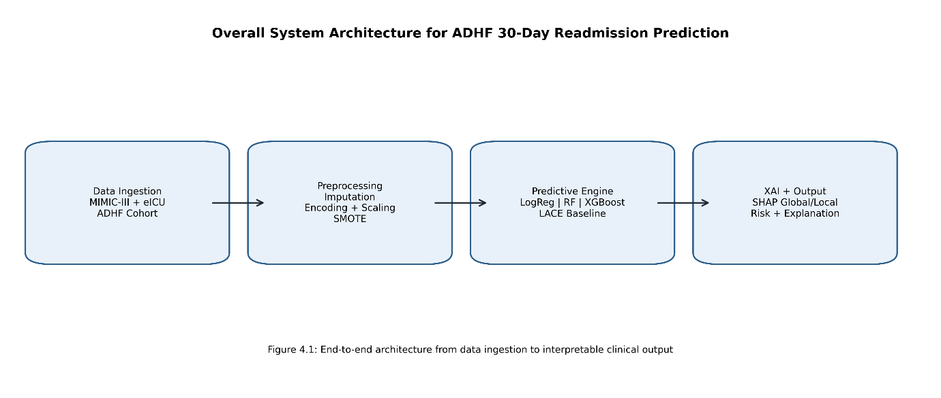
Figure 4.1 illustrates the full processing path used in this dissertation. First, ADHF cohort data are ingested from MIMIC-III and eICU-style structures. Second, preprocessing operations standardize and clean the data, including imputation, encoding, scaling, and class-imbalance correction. Third, the predictive engine evaluates candidate models and computes readmission probabilities. Finally, the explainability layer produces global and local SHAP interpretations, and the output layer returns clinically readable risk categories with supporting feature attributions.
Architecturally, this modular design provides three advantages. It separates concerns between data engineering, prediction, and explanation; it supports reproducible experimentation through a deterministic pipeline; and it provides a deployment-ready structure in which prediction and interpretability are generated together rather than as disconnected tasks.

4.3 Design of the ADHF Readmission Prediction Model

4.3.1 Model Architecture and Design Rationale
The predictive design follows a comparative multi-model strategy with Logistic Regression, Random Forest, and XGBoost as candidate learners, and LACE as the conventional non-ML benchmark. In the present system, Random Forest is adopted as the primary predictive engine due to its robustness in tabular clinical data, its ability to capture non-linear interactions, and its stable performance under moderate feature heterogeneity.
The model receives a structured feature vector containing demographic, physiological, laboratory, and comorbidity variables relevant to ADHF outcomes. During training, bootstrapped samples are used to build an ensemble of decision trees. During inference, each tree contributes a class probability, and the forest aggregates these outputs into a final readmission probability.
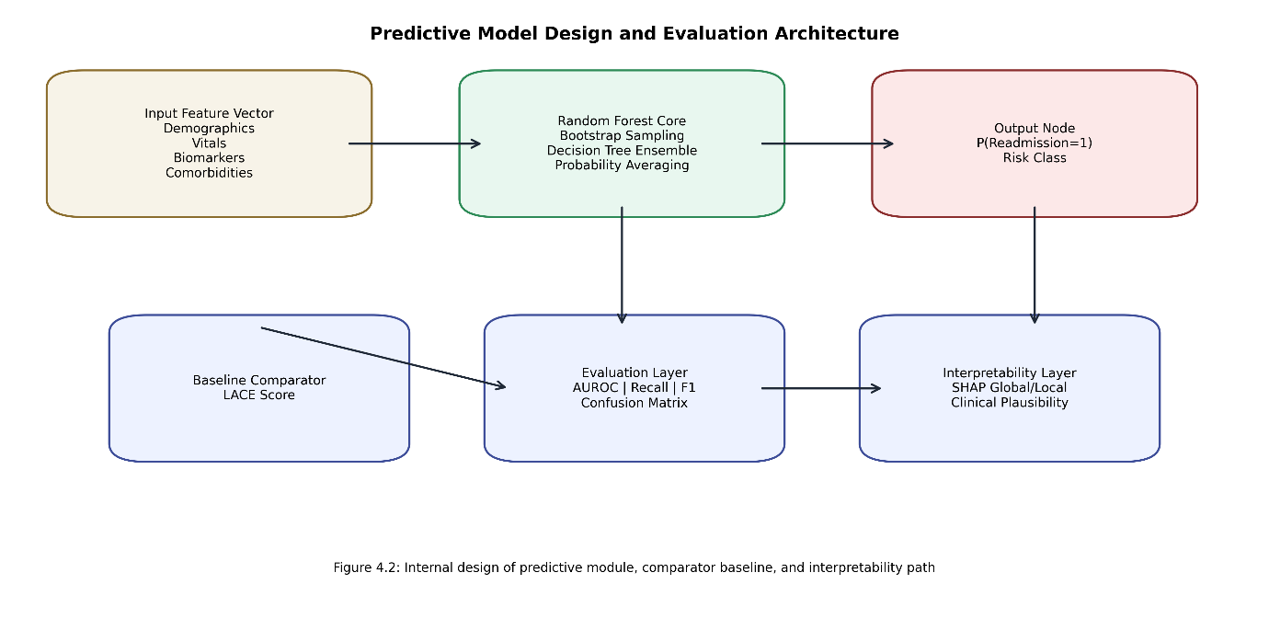
As shown in Figure 4.2, the predictive core is not used in isolation. The architecture includes an explicit LACE baseline path and an evaluation layer that computes clinical-performance metrics on identical partitions. This design ensures fair comparisons and prevents subjective model preferences. The interpretability layer is attached to the final predictive core so that feature-level explanations always accompany output risk scores.

4.3.2 Mathematical Formulation
The prediction target is binary readmission risk:
$$y∈\{0,1\},y=1\text{ indicates readmission within 30 days.}$$
For Random Forest with $T$ Trees, the predicted probability for class 1 is:
$$\hat{p}(x)=\frac{1}{T}\sum_{t=1}^{T}{p_{t}}(y=1∣x),$$
where $p_{t}(y=1∣x)$ Is the class-1 probability from the tree? $t$ for input $x$.
The final class decision is:
$$\hat{y}=I(\hat{p}(x)≥τ),$$
where $τ$ is a decision threshold (default $0.5$, tunable for recall-sensitive clinical operation).
At each split node, tree construction minimizes impurity, commonly using Gini impurity:
$$G(S)=1-\sum_{k=1}^{2}{p_{k}^{2}},$$
where $p_{k}$ is the class proportion of the class $k$ in subset $S$.
For benchmark comparison, the LACE score is computed on the same test cohort and compared against ML outputs using clinically relevant metrics (AUROC, recall, F1, AUPRC). This ensures that statistical performance gains are explicitly demonstrated rather than assumed.

4.3.3 Design-Level Code Realization
The implemented design in the project backend clearly separates the preprocessing and training stages.
Representative training-stage realization:
rf = RandomForestClassifier(random_state=42)
param_grid = {
"n_estimators": [50, 100, 200],
"max_depth": [5, 10, 15, None],
"min_samples_split": [2, 5, 10],
}
grid_search = GridSearchCV(estimator=rf, param_grid=param_grid, cv=3, n_jobs=-1)
grid_search.fit(X_train, y_train)
best_rf = grid_search.best_estimator_
Representative preprocessing-stage realization:
imputer = KNNImputer(n_neighbors=5)
X_num = imputer.fit_transform(X_num)
X_balanced, y_balanced = SMOTE(random_state=42).fit_resample(X, y)
X_scaled = StandardScaler().fit_transform(X_balanced)

These snippets are included to demonstrate architectural traceability from design intent to implementation logic. Full implementation details and complete source walkthroughs are provided in the implementation chapter and appendices.

4.4 Explainable AI (XAI) Integration Design

4.4.1 Explanation Generation Mechanism
XAI is integrated as a core design requirement to avoid black-box deployment in a high-stakes clinical context. SHAP is used as a wrapper explainer around the trained predictive model. The explainer estimates the marginal contribution of each feature to each prediction using the Shapley value principles from cooperative game theory.
For a model $f$ and feature set $F$, the SHAP value for the feature $i$ is:
$$ϕ_{i}=\sum_{S⊆F∖\{i\}}{\frac{∣S∣!(∣F∣-∣S∣-1)!}{∣F∣!}}\left[f(S∪\{i\})-f(S)\right].$$
This formulation quantifies how much the feature. $i$ contributes, on average, across all coalition orderings.

4.4.2 Explanation Output Design
The system is designed to generate two complementary explanation views.
- Global explanations: aggregated feature-impact summaries over the evaluation cohort, used to identify dominant risk drivers.
- Local explanations: patient-specific decomposition showing how each feature pushes prediction from baseline risk toward high or low readmission probability.
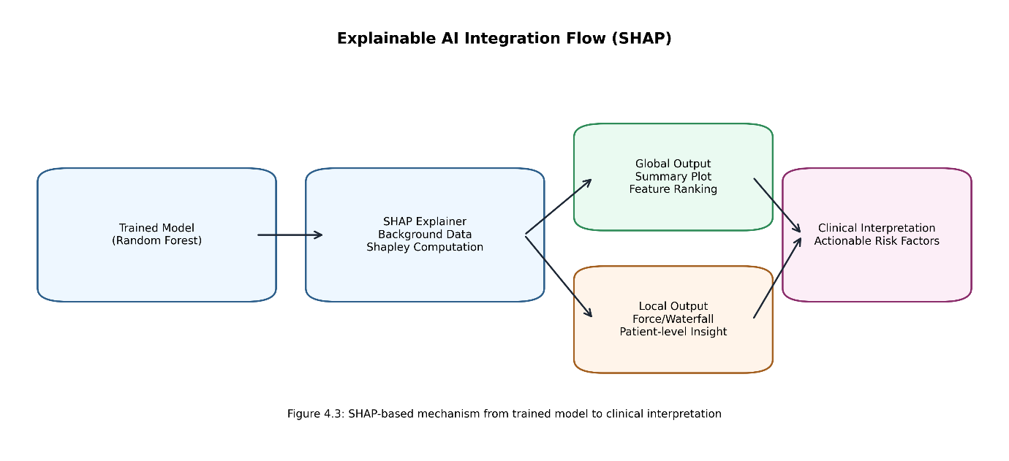
Figure 4.3 shows the explanation pipeline from the trained model to clinical interpretation. The output design ensures that every risk score can be audited at the patient level and that cohort-level behavior can be checked for medical plausibility. In the ADHF context, this is critical for validating the role of biomarkers, frailty proxies, and discharge stability signals.

4.4.3 Clinical Interpretation Layer
The final explanation layer translates raw SHAP outputs into clinician-usable narratives. Features with positive SHAP values are interpreted as risk-increasing contributors, while negative SHAP values are interpreted as protective contributors. This directional interpretation supports discharge planning by indicating why a patient is flagged as high risk and which factors should be prioritized for intervention.

4.5 Chapter Summary
This chapter has presented the full process and model design of the proposed ADHF readmission system. The chapter defined the end-to-end architecture, detailed the predictive model blueprint, formalized the learning and inference equations, and described the SHAP-centered explainability design with corresponding architecture diagrams. By integrating predictive modeling, baseline benchmarking, and transparent explanation into one coherent design, the chapter establishes the technical foundation required for implementation execution and empirical result analysis in the next chapter.

REFRENCES
[1] F. Foroutan et al., “Global Comparison of Readmission Rates for Patients With Heart Failure,” J. Am. Coll. Cardiol., vol. 82, no. 5, pp. 430–444, Aug. 2023, doi: 10.1016/j.jacc.2023.05.040.
[2] V. M. Wauye, D. Ahadzi, K. Udayakumar, and G. T. Ngeno, “Heart Failure in Sub-Saharan Africa: Current and Future Systems of Care,” Journal of Asian Pacific Society of Cardiology, vol. 4, May 2025, doi: 10.15420/japsc. 2024.37.
[3] Hamed Hajishah, “Open Access”, doi: 10.1186/s12872-025-04700-0.
[4] N. Alnomasy et al., “Predictive Performance of Machine Learning Models for Heart Failure Readmission: A Systematic Review,” Biomedicines, vol. 13, no. 9, Sep. 2025, doi: 10.3390/biomedicines13092111.
[5] Y. Zhang et al., “Explainable machine learning for predicting 30-day readmission in acute heart failure patients,” iScience, vol. 27, no. 7, Jul. 2024, doi: 10.1016/j.isci.2024.110281.
[6] L. Wang, C. Wei, Y. Chen, D.-S. Lu, H.-X. Zhang, and M. Yang, “Machine learning-based prediction model for 30-day readmission risk in elderly patients with type 2 diabetes mellitus and heart failure: a retrospective cohort study with SHAP interpretability analysis,” Front. Cardiovasc. Med., vol. 12, Jan. 2026, doi: 10.3389/fcvm. 2025.1673159.
[7] Y. Huang, A. Talwar, S. Chatterjee, and R. R. Aparasu, “Application of machine learning in predicting hospital readmissions: a scoping review of the literature”, doi: 10.1186/s12874-021-01284-z.
[8] K. Iwata et al., “Clinical impact of functional independent measure (FIM) on 180-day readmission and mortality in elderly patients hospitalized with acute decompensated heart failure,” Heart Vessels, vol. 36, no. 10, pp. 1536–1541, 2021, doi: 10.1007/s00380-021-01841-y.
[9] W. J. Siddiqui et al., “Readmission rate after ultrafiltration in acute decompensated heart failure: a systematic review and meta-analysis,” 2017, doi: 10.1007/s10741-017-9650-3.
[10] B. Ru et al., “Comparison of Machine Learning Algorithms for Predicting Hospital Readmissions and Worsening Heart Failure Events in Patients With Heart Failure With Reduced Ejection Fraction: Modeling Study”, doi: 10.2196/41775.
[11] M. Sabouri et al., “Machine learning based readmission and mortality prediction in heart failure patients,” Sci. Rep., vol. 13, no. 1, p. 18671, 2023, doi: 10.1038/s41598-023-45925-3.
[12] A. M. Salih et al., “A Perspective on Explainable Artificial Intelligence Methods: SHAP and LIME,” Advanced Intelligent Systems, vol. 7, no. 1, p. 2400304, Jan. 2025, doi: 10.1002/aisy.202400304.
[13] L. Grossman Liu et al., “Published models that predict hospital readmission: a critical appraisal,” BMJ Open, vol. 11, no. 8, p. e044964, 2021, doi: 10.1136/bmjopen-2020-044964.
[14] B. Zang, C. Li, M. Zhou, and Y. Chao, “Interpretable Machine Learning Model for Predicting 30‐Day Readmission in Advanced Heart Failure Patients: Synergistic Assessment of Inflammatory and Metabolic Biomarkers,” Cardiovasc. Ther., vol. 2026, no. 1, p. 2307901, 2026, doi: 10.1155/cdr/2307901.
[15] Y. Hu, F. Ma, M. Hu, B. Shi, D. Pan, and J. Ren, “Development and validation of a machine learning model to predict the risk of readmission within one year in HFpEF patients: Short title: Prediction of HFpEF readmission,” Int. J. Med. Inform., vol. 194, Feb. 2025, doi: 10.1016/j.ijmedinf.2024.105703.
[16] A. M. Salih et al., “A Perspective on Explainable Artificial Intelligence Methods: SHAP and LIME,” Advanced Intelligent Systems, vol. 7, no. 1, Jan. 2025, doi: 10.1002/aisy.202400304.
[17] J. Allgaier, L. Mulansky, R. L. Draelos, and R. Pryss, “How does the model make predictions? A systematic literature review on the explainability power of machine learning in healthcare,” Artif. Intell. Med., vol. 143, p. 102616, 2023, doi: 10.1016/j.artmed.2023.102616.
[18] H. Luo et al., “SHAP based predictive modeling for 1 year all-cause readmission risk in elderly heart failure patients: feature selection and model interpretation,” Sci. Rep., vol. 14, no. 1, Dec. 2024, doi: 10.1038/s41598-024-67844-7.
[19] S. X. Zhao, X. long Wang, and Q. sheng Yue, “A Novel Mixed Sampling Algorithm for Imbalanced Data Based on XGBoost,” Communications in Computer and Information Science, vol. 1321, pp. 181–196, 2020, doi: 10.1007/978-981-33-4214-9_14.
[20] Md. Rahman et al., “Heart Failure Emergency Readmission Prediction Using Stacking Machine Learning Model,” Diagnostics, vol. 13, no. 11, p. 1948, 2023, doi: 10.3390/diagnostics13111948.
[21] K. Kumar, K. Chaudhury, and S. L. Tripathi, “Future of Machine Learning ( ML ) and Deep Learning ( DL ) in Healthcare Monitoring System,” Machine Learning Algorithms for Signal and Image Processing, pp. 293–313, Nov. 2022, doi: 10.1002/9781119861850.ch17.
[22] P. Shakya, A. Khaneja, and K. B. Wagholikar, “Predicting 30-Day Hospital Readmission for Patients with Heart Failure Using Electronic Health Record Embeddings: Comparative Evaluation,” JMIR Med. Inform., vol. 13, no. 1, p. e73020, Nov. 2025, doi: 10.2196/73020.
[23] S. D. Mohanty, D. Lekan, T. P. McCoy, M. Jenkins, and P. Manda, “Machine learning for predicting readmission risk among the frail: Explainable AI for healthcare,” Patterns, vol. 3, no. 1, Jan. 2022, doi: 10.1016/j.patter.2021.100395.
[24] C. Okoye et al., “Predicting mortality and re-hospitalization for heart failure: a machine-learning and cluster analysis on frailty and comorbidity,” vol. 35, pp. 2919–2928, 2023, doi: 10.1007/s40520-023-02566-w.
[25] L. Mpofu, B. Ndlovu, S. Dube, M. Muduva, F. Jacqueline, and K. Maguraushe, “Predictive Model for Hospital Readmission of Diabetic Patients,” in 5th African International Conference on Industrial Engineering and Operations Management, IEOM Society International, 2024. doi: 10.46254/AF05.20240252.
[26] T. Rizinde, I. Ngaruye, and N. D. Cahill, “Comparing Machine Learning Classifiers for Predicting Hospital Readmission of Heart Failure Patients in Rwanda,” J. Pers. Med., vol. 13, no. 9, Sep. 2023, doi: 10.3390/jpm13091393.
[27] J. Zeng et al., “Construction of risk prediction model for predicting death or readmission in acute heart failure patients during vulnerable phase based on machine learning,” Journal of Army Medical University, vol. 46, no. 7, pp. 738–745, 2024, doi: 10.16016/j.2097-0927.202312147.
[28] A. Pikatza-Huerga et al., “Machine learning approaches for predicting heart failure readmissions,” Postgrad. Med. J., vol. 101, no. 1202, pp. 1351–1360, Dec. 2025, doi: 10.1093/postmj/qgaf102.
[29] U. Tokac, J. Chipps, P. Brysiewicz, J. Bruce, and D. Clarke, “Using Machine Learning to Improve Readmission Risk in Surgical Patients in South Africa,” Int. J. Environ. Res. Public Health, vol. 22, no. 3, Mar. 2025, doi: 10.3390/ijerph22030345.
[30] L. Mpofu, B. Ndlovu, S. Dube, M. Muduva, F. Jacqueline, and K. Maguraushe, “Predictive Model for Hospital Readmission of Diabetic Patients,” in 5th African International Conference on Industrial Engineering and Operations Management, IEOM Society International, 2024. doi: 10.46254/AF05.20240252.
[31] L. Grossman Liu and others, “Published models that predict hospital readmission: a critical appraisal,” BMJ Open, vol. 11, no. 8, p. e044964, 2021, doi: 10.1136/bmjopen-2020-044964.
[32] M. Sabouri and others, “Machine learning based readmission and mortality prediction in heart failure patients,” Sci. Rep., vol. 13, no. 1, p. 18671, 2023, doi: 10.1038/s41598-023-45925-3.
[33] Y. Huang, A. Talwar, S. Chatterjee, and R. R. Aparasu, “Application of machine learning in predicting hospital readmissions: a scoping review of the literature,” 2021, doi: 10.1186/s12874-021-01284-z.
[34] S. S. Band and others, “Application of explainable artificial intelligence in medical health: A systematic review of interpretability methods,” Inform. Med. Unlocked, vol. 40, no. 3, p. 101286, Jan. 2023, doi: 10.1016/j.imu.2023.101286.
[35] J. Allgaier, L. Mulansky, R. L. Draelos, and R. Pryss, “How does the model make predictions? A systematic literature review on the explainability power of machine learning in healthcare,” Artif. Intell. Med., vol. 143, p. 102616, 2023, doi: 10.1016/j.artmed.2023.102616.
[36] S. D. Mohanty, D. Lekan, T. P. McCoy, M. Jenkins, and P. Manda, “Machine learning for predicting readmission risk among the frail: Explainable AI for healthcare,” Patterns, vol. 3, no. 1, Jan. 2022, doi: 10.1016/j.patter.2021.100395.
[37] K. Iwata and others, “Clinical impact of functional independent measure (FIM) on 180-day readmission and mortality in elderly patients hospitalized with acute decompensated heart failure,” Heart Vessels, vol. 36, no. 10, pp. 1536–1541, 2021, doi: 10.1007/s00380-021-01841-y.
[38] C. Okoye and others, “Predicting mortality and re-hospitalization for heart failure: a machine-learning and cluster analysis on frailty and comorbidity,” vol. 35, pp. 2919–2928, 2023, doi: 10.1007/s40520-023-02566-w.
[39] J. Allgaier, L. Mulansky, R. L. Draelos, and R. Pryss, “How does the model make predictions? A systematic literature review on the explainability power of machine learning in healthcare,” Artif. Intell. Med., vol. 143, p. 102616, 2023, doi: 10.1016/j.artmed.2023.102616.
[40] S. X. Zhao, X. L. Wang, and Q. S. Yue, “A Novel Mixed Sampling Algorithm for Imbalanced Data Based on XGBoost,” in Communications in Computer and Information Science, 2020, pp. 181–196. doi: 10.1007/978-981-33-4214-9_14.
[41] E. A. Felix and S. P. Lee, “Systematic literature review of preprocessing techniques for imbalanced data,” 2019, doi: 10.1049/iet-sen.2018.5193.

